**Course Code**: [CS-1001L] **Course Title:** [PF]

**Class/Section: 1B1/1B2 Time allowed: 2 days**

**Course Instructor: MALEEHA SHAH**  **Max Marks: 05**

**Question 01:**

Create a program that asks the user for marks of subjects, save them and then print these marks.

Input:

**Sample Output:**

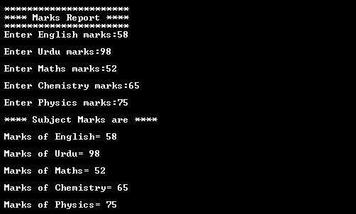

**Question 02:**

Write a program that asks the number of years to user in which the employee joined the organization are entered through the keyboard. If the number of years for which the employee has served the organization is greater than 3 then a bonus of Rs. 2500/- otherwise no bonus is given

**Sample Output:**

